Arch 7104 Diploma Studio_Graduate Research-Design Studio 6 Credits Spring 2023 MWF 2-5:15pm Dubois 1002
Chris Jarrett, Professor Office Hours M 1-2pm (chjarrett@uncc.edu) School of Architecture I University of North Carolina at Charlotte

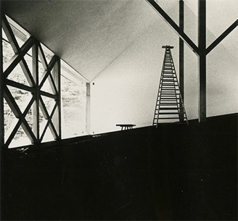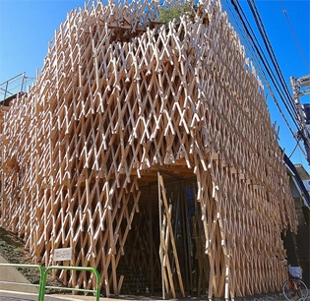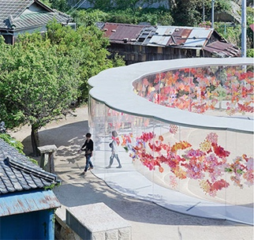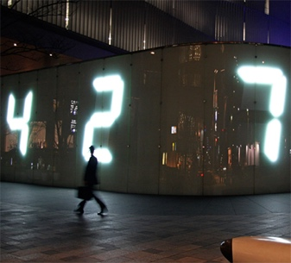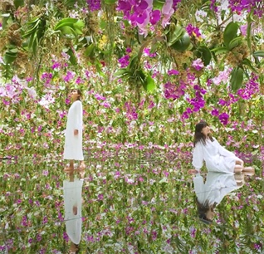

Tanikawa House, 1972 Urban Forest (cake shop) A-Art House, Inujima Island Counter Void Simulated Water Garden

Kazuo Shinohara Kengo Kuma Kazuyo Sejima Tatsuo Miyajima TeamLab

CRITICAL ECOLOGIES

… decarbonization is not solely a question of technology and building systems, but also a theoretical question for architecture and the city.

Daniel Barber’s essay, After Comfort, critically interrogates the ecology of comfort. Comfort, he argues, is tightly bound up with gross quantities of consumption and carbon emissions. Barber posits that the contemporary discourse and practices of comfort is, in essence, destroying our future. He writes at length about all the ways that comfort – a condition of modernity – undermines not only the health of our environment but our literacy of place. Barber argues that it’s time to renegotiate the relationship between comfort, culture and carbon. This unlikely and provocative charge to rethink comfort in the 21st c. aligns well with the central discourse of this diploma studio, namely ecocriticism.

Ecocriticism is loosely defined as the study of the mutually constructing relationship between culture and the environment. Emerging from literary and cultural studies, ecocriticism defines the role the natural environment plays in the imagination of a cultural community (or nation). It examines how the concept of "nature" is defined, what values are assigned to it or denied it, and why. It is in this dialogic space between culture and environment that this studio is situated and where complexity will be nurtured.

The locus for this research is Japan. Entering the eastern hemisphere opens up new eco-social practices respectful of all forms of being, including inanimate objects. Japan’s immersive attention to the environment reflects its diverse archipelago geography, from the drift ice in Hokkaido to the mangrove forests in Okinawa. Such landscapes are transposed into paintings, domestic gardens and neighborhood pocket parks. This is not to say that Japan is free of environmental criticism. As as an island-nation, there is both beauty and inherent resource poverty. Located along the pacific ring of fire, Japan is vulnerabie to grave natural disasters (e.g. earthquakes, tsunamis). Modern environmental deterioration in the name of economic prosperity has been climbing since the 1980’s, from gross amounts of waste to abhorrent whaling to a persistent reliance on coal. Not that global environmental treaties and accords aren’t signed. Arguably, when the east-west divide is examined ideologically rather than geographically, Japan could be classified as an equal partner in the problem of global environmental deterioration. These tensions will be the subject of study and design.

The book Ecocritism in Japan (Waki, Suga, Masami, ed. 2018) will serve as a research platform for cultivating an eco-critical literacy of place. Each student will select a chapter in this book and excavate their diploma project from it. Identifying specific problems or dilemmas raised by the author will serve as the initial site of inquiry for research and design. Sample problems include consumption, plastic packaging and waste, massive food transport, work obsession, anime, manga and the dark side of gaming, changing demographics, patriarchy and gender inequality, patrimony and rising land values, earthly volatility and radiation, nonrenewable energy dependency, beef culture, to name a few. In this studio, sites and programs are open and experimental yet derivative of their research and creative line of thinking.

The field of ecocriticism reminds us (humans) of our placement within ecosystems and the importance of this fact for understanding life. This relatively new domain of critical theory provides the parameters that offer the ecological component often missing from cultural analyses of the city and the urban perspective often lacking in environmental responses to contemporary culture. The objective of this studio is to advance a series of “critical ecologies” in the context of understanding place as a contested field between cultural and environmental forces. Students will be encouraged to program anew, in uncomfortable ways, that contribute to our understanding of place and the real problems at work.

Elena Iturbe, Architecture and the Death of Carbon Modernity, Log 47, Anyone Corporation, 2019
See Michael Bennett and David Teague, The Nature of Cities: Ecocriticism and Urban Environments, Tucson: The University of Arizona Press, 1999.
The dialogic concept is when a word, discourse, language, meaning (or building) becomes deprivileged, relativized, and aware of competing definitions.
Reference the 19th c. wood block prints of artist Hokusai
The Diplomat, Elliot Silverberg and Elizabeth Smith, 2019
Reference images of projects at the top of this page.

